Day 4 : Webscrapping, survey weight handling and workshop
Session 13: Webscrapping, duplicates, and missing data
  - Webscrapping

E028-webscrapping.R
#-----------------------------------------------------------------
# importing csv data directly from the web
#-----------------------------------------------------------------
df <- read.csv("http://s.anilz.net/wb_energy")
head(df)

dx <- read.csv("https://data.ny.gov/api/views/d6yy-54nr/rows.csv")
head(dx)

#-----------------------------------------------------------------
# Using rvest package for static website scraping
#-----------------------------------------------------------------
#loading necessary packages
library(rvest) #see https://rvest.tidyverse.org/articles/harvesting-the-web.html for details
library(dplyr)

#loading webpage content
webpage <- read_html("https://www.sharesansar.com/today-share-price")

#extracting table from the webpage
tables <- html_table(webpage)

#checking the number of tables available in the webpage
length(tables)

df1 <- tables[[1]]
head(df1)

#filtering upper and lower circuit stock
filtered_df1 <- df1 %>% filter(`Diff %` > 9 | `Diff %`< -9) %>% arrange(`Diff %`)
filtered_df1

#*************************************
#*Obtaining Forex information from NRB
#*************************************
#loading webpage content
webpage <- read_html("https://www.nrb.org.np")

#extracting table from the webpage
tables <- html_table(webpage)

#checking the number of tables available in the webpage
length(tables)

df1 <- tables[[1]]
df2 <- tables[[2]]

df1
df2

#keeping USD and JPY only
filtered_df1 <- df1 %>% filter(Currency=='USD' | Currency =='JPY')
filtered_df1
Task 6 :
Web-scrape the Historical ranking table from https://en.wikipedia.org/wiki/ICC_Men%27s_T20I_Team_Rankings

webpage <- read_html("https://en.wikipedia.org/wiki/ICC_Men%27s_T20I_Team_Rankings")
tables <- html_table(webpage)
length(tables)

df <- tables[[7]]

  - Finding duplicates
E029-duplicates.R
library(dplyr)

# Creating a sample data frame
df <- data.frame(
ID = c(1, 2, 3, 3, 4, 5, 4, 3),
Name = c("John", "Jane", "Mark", "Mark", "Luke", "Kate", "Luke", "Mark"),
Age = c(25, 30, 35, 35, 40, 45, 40, 35)
)

df
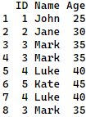

#showing the duplicated observations
df %>% filter(duplicated(.) == T)
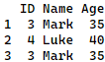

#removing the duplicated observations
df %>% filter(!duplicated(.) == T)
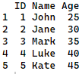

#counting the duplicate observations
df %>% group_by_all() %>%
summarise(count = n()) %>%
filter(count > 1)
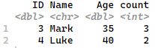

#identifying duplicate values based on some variables
library(haven)
df <- read_dta('data/008-nlfs2.dta')

#checking whether there is any duplicate based on selected variables
df %>% count(psu, hhid) %>% filter(n > 1)
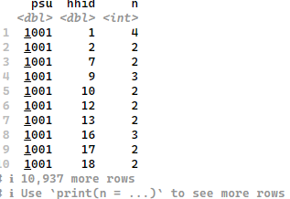

#selecting observations that does not have duplicate based on selected variables
df %>% filter(duplicated(psu, hhid) == F) %>% count(psu, hhid)
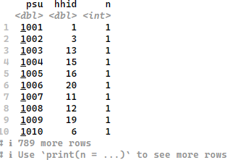

  - Finding missing values
E030-missing_values.R
library(haven)
library(dplyr)
df <- read_dta('data/008-nlfs2.dta')
df <- df[c('psu','hhid','q13','q18')]

#Selecting observations with no missing values
df %>% filter(complete.cases(.) == T)

#Selecting observations with missing values
df %>% filter(complete.cases(.) == F)

Session 14: Using survey weights
library(survey) #for survey data
library(haven) #for importing Stata dta file
library(srvyr) # srvyr' for tidyverse-style coding (easier to read)

#function for directly accessing the data from the web
get_url <- function(x) {
return(paste0("https://github.com/tempgita/training/raw/refs/heads/master/R%20training%202082-10-03/data/",x))
}

df <- read_stata(get_url('013-poverty.dta'))

svy_design <- svydesign(
ids = ~psu_number,
strata = ~domain,
weights = ~hhs_wt,
data = df
)

svy_obj <- as_survey(svy_design)

#*==================================================
#*Population size calculation
#*==================================================
#The manual way
df %>% summarise(hh_pop = sum(hhs_wt),
ind_pop = sum(ind_wt))

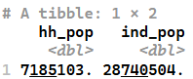

df %>%
group_by(prov) %>%
summarise(hh_pop = sum(hhs_wt),
ind_pop = sum(ind_wt))
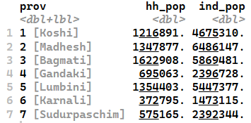
#using the survey object
svy_obj %>%
summarise(pop_size = survey_total())
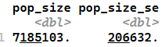
svy_obj %>%
group_by(prov) %>%
summarise(pop_size = survey_total())
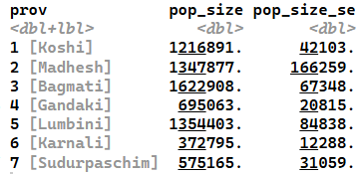
#*==================================================
#* Mean calculation
#*==================================================
# the manual way
df %>%
summarise(pcep_mean = weighted.mean(pcep, hhs_wt))
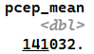
df %>%
group_by(prov) %>%
summarise(pcep_mean = weighted.mean(pcep, hhs_wt))
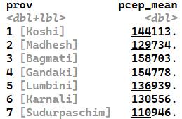
#using the survey object
svy_obj %>%
summarise(mean_pcep = survey_mean(pcep))
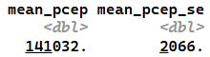
svy_obj %>%
group_by(prov) %>%
summarise(mean_pcep = survey_mean(pcep))
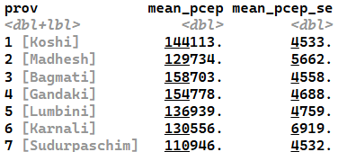
#*==================================================
#* Calculation of poor proportion
#*==================================================
svy_obj %>%
group_by(prov) %>%
summarise(poverty_rate = survey_mean(poor,
vartype = c("se", "ci"),
level = 0.95)) # for CI at 5% level of significance
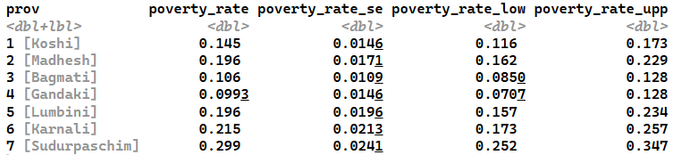
#*==================================================
#* Quantiles
#*==================================================
# --- Using the Survey Object ---
# Calculate Median PCEP by Province
svy_obj %>%
group_by(prov) %>%
summarise(
median_pcep = survey_median(pcep),
q90 = survey_quantile(pcep, quantiles = 0.9)
)
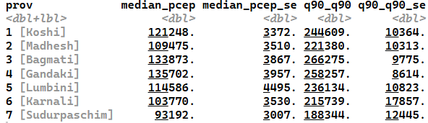
#*==================================================
#* Ratio Estimation
#*==================================================
svy_obj %>%
group_by(prov) %>%
summarise(
food_share = survey_ratio(numerator = pcep_food,
denominator = pcep)
)
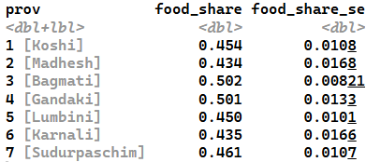

#*==================================================
#* t-test
#*==================================================
svyttest(pcep ~ poor, design = svy_obj)
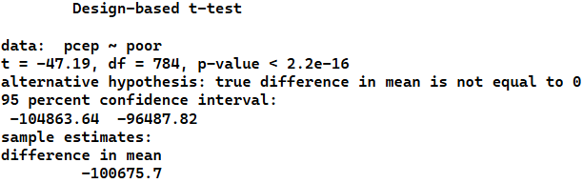
#OR
summary(svyglm(pcep ~ poor, design = svy_obj))
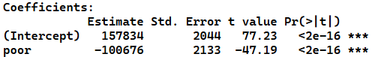

Task: perform t-test between the mean pcep between Madhesh vs Karnali and Madhesh vs. Bagamati.
#*==================================================
#* T-test (Comparing Means between two groups)
#*==================================================
# --------- Madhesh vs Karnali -----------------
# Step 1: Create a subset design object for the two provinces
sub_obj <- svy_obj %>%
filter(prov %in% c(2, 6)) %>%
mutate(prov_binary =as.factor(prov)) #to make prov binary variable

# Step 2: Run the test using the new binary variable
svyttest(pcep ~ prov_binary, design = sub_obj)
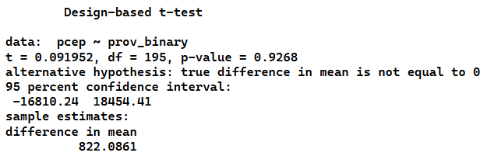
#OR
summary(svyglm(pcep ~ prov_binary, design = sub_obj))
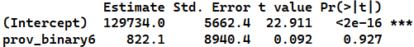
# --------- Madhesh vs Bagamati -----------------
# Step 1: Create a subset design object for the two provinces
sub_obj <- svy_obj %>%
filter(prov %in% c(2, 3)) %>%
mutate(prov_binary =as.factor(prov)) #to make prov binary variable

# Step 2: Run the test using the new binary variable
svyttest(pcep ~ prov_binary, design = sub_obj)
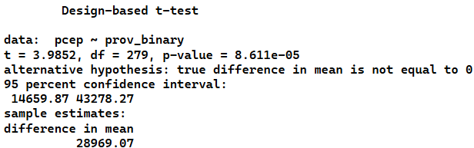
#OR
summary(svyglm(pcep ~ prov_binary, design = sub_obj))
